Proposal for - National / International
GOVERNMENT COLLEGE OF ENGINEERING SALEM-11
Technical Education Quality Improvement Programme (TEQIP – III)
Proposal for Attending Conference / Workshop/Short term course/Seminar/Training Courses
Name of the Student/Student Coordinator

Year:

Department:
UG/PG:
E-mail:
Total Number of Students Participating:
Mobile No:
How this is relevant to the project objective?
Name of the Conference / Training Course/Others #
Place (s) of the Conference / Training Course / Place of visit
Date of Departure
Duration with dates
Date of arrival at institute
Organizer of the Conference / Training Course / Place of visit with full address
For Conference write the title paper / for Training Course (or other visit) write purpose for both give justification with special
reference to New PG courses and research activities carried out at PEC.
Total Cost involved Rs. ______________(Rupees ___________________________________________________only)
Please give the details [Registration Fee, Travel cost within India / abroad, per day cost, others, if any (special)] of the total in the back.
Whether entitled to travel by air: YES/ NO. If No, special permission should be sought from the highest authority
Whether any advance will be required YES/ NO, If YES, Rs. …………………………..
Check List (please √)
a) Leave approved by authority
b) Nine days restriction during semester
c) Copy of paper to be presented/ proper
justification
d) Whether attended conference/ workshop
etc under TEQIP/ institute grant in academic
year (give details)
Forwarded and recommended with a
note given in the back
Forwarded and Recommendation
Signature of the Class Advisor/Coordinator
Signature with date & seal of the
Departmental Head
Recommended
Signature of the Nodal
Officer (Academic Activities), TEQIP - III
Approved / Not Approved
[Signature (with seal) of the
Nodal Officer (Finance), TEQIP – III]
[Signature (with seal) of the
Co-ordinator (TEQIP – III)]
[Signature (with seal) of the
PRINCIPAL
Note: In case of International travel prior approval of BOG is required.
# Nodal Officer, Academic Activities / Co-ordinator, TEQIP –III to note Category of Expenditure (see overleaf).
* Attach all relevant matters

Category of Expenditure (Put Tick in one Box)
To be filled Nodal Officer/ Academic Activities
(TEQIP – III)
The visit of (Name of the Student/Student Coordinator) ____________________________________________________________________________
to (name of places / course) _____________________________________________________________will benefit the department
with specific area in the following way
The necessary alternative arrangement for classes /other duties of the faculty / staff have been made by the faculty/ staff. Does the
duration of leave overlap with examination period? If yes, give special reasons for allowing faculty/ staff to attend the event.
Signature (with seal) of the Head ____________________________ Dept. / ________________
Details of the budget with breakup
Sl.
No.
[TA is admissible as per the eligibility depending on the basic of pay]
Particulars
Amount (Rs.)
Remarks
TOTAL
ADVANCE
In view of the approval given by the competent authority sanction amounting to Rs.__________ as an advance may please be accorded.
Signature of the Student / Representative

Nodal Officer Finance
Please release the payment.
Nodal office (Finance)*
Received Rs. ____________________as advance, vide Cheque No. __________________ dated ___________________. The advance
will be adjusted within 15 working days from the return to the Institute.
Signature of the Student / Representative
Place for necessary noting of the Finance Section of TEQIP - III
Coordinator
Director
*Budgetary provision is checked
@ A brief report indicating the outcome of the training courses, conferences etc. should be submitted, through HOD, in duplic ate [one for
Nodal Officer (TEQIP –III), Academic Activities (TEQIP – III) and another for Co-ordinator , TEQIP –III ) at the time of submission of final bills.

Enhancement of R & D and institutional consultancy activities
Faculty and Staff Development for improved competence based on TNA
Enhanced interaction with industry
Institutional Management Capacity Enhancement
Implementation of Institutional Reforms
Academic Support for Weak Students
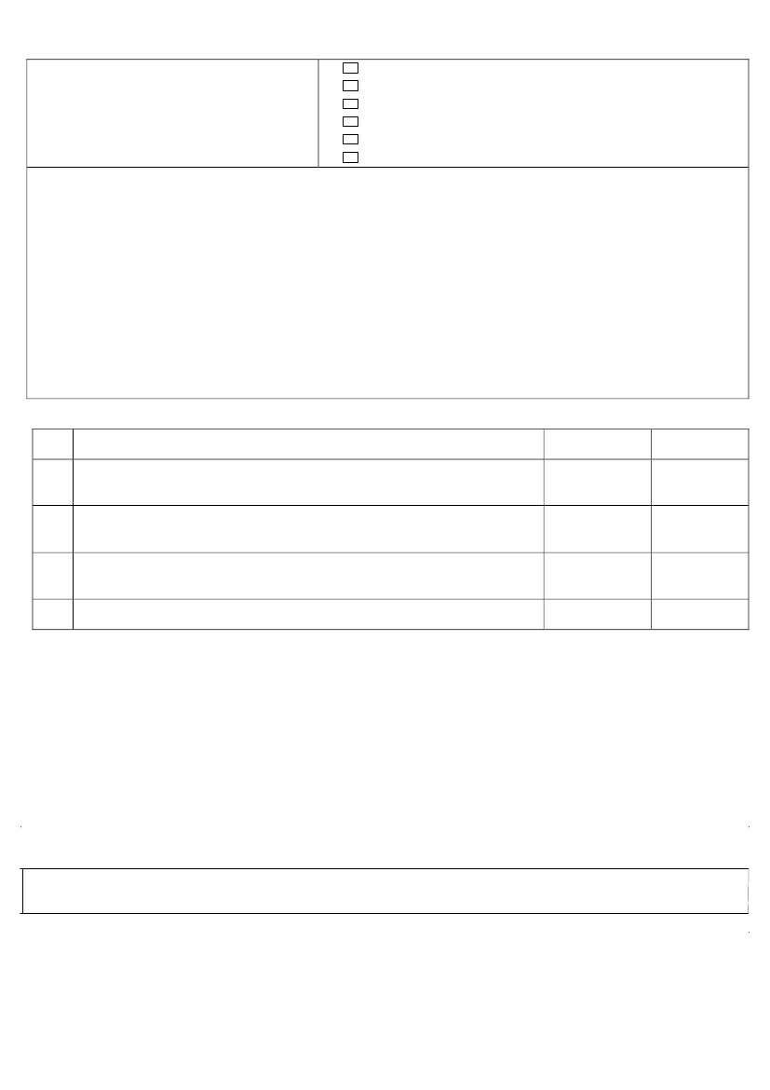

GOVERNMENT COLLEGE OF ENGINEERING,SALEM-636011
TEQIP PHASE-III
Bank Details for Attending Conference / Workshop/Short term course/Seminar/Training Courses

Name of the Student/Student Coordinator: | Department:
Father Name: | Date of Birth (DD/MM/YYYY):
Aadhaar Number: | PAN Number:
Address1: | City:
District: | State:
Pin Code: | Country:
Mobile No: | Email:
Bank Name: | Branch Name:
Account No: | IFSC Code:
Name of the Conference / Training Course/Others #

How this is relevant to the project objective?

Place (s) of the Conference / Training Course / Place of visit

Duration with dates

Cost involved

Signature of the Student/
Student Coordinator
Date:

Signature of the Class Advisor | Signature of the Head of the Department

Approved/Not approved
The expenditure will be booked under key activity…………………….
(For issuance of sanction order)

Nodal Officer Academics | Nodal Officer Finance | Coordinator TEQIP-III | Principal

